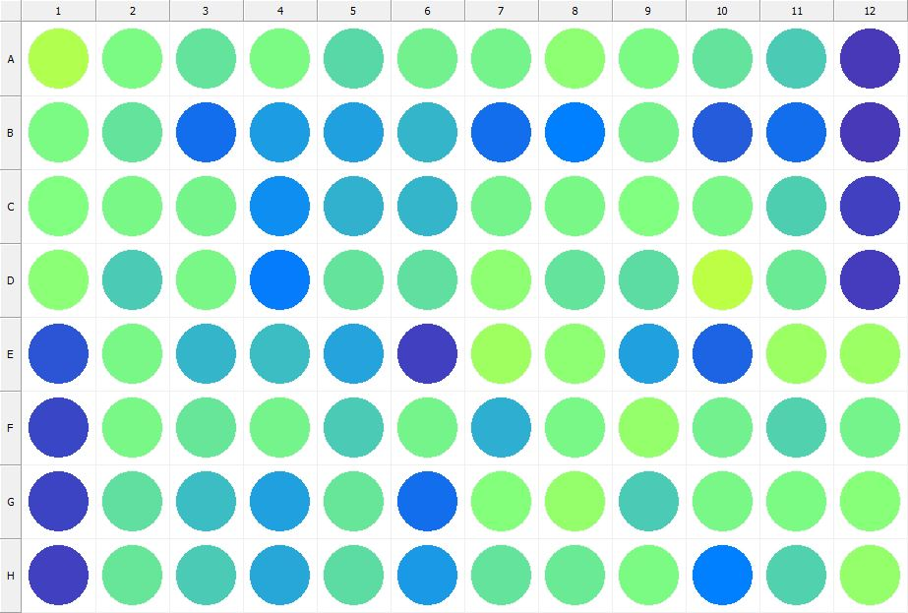

|  |
| --- |
| **Results for Tim_CTB(1) - channel 1 (RFU) - Plate information/ Compound at 2 uM + DMSO_R1** |

|  |  |  |  |  |  |  |  |  |  |  |  |  |
| --- | --- | --- | --- | --- | --- | --- | --- | --- | --- | --- | --- | --- |
|  | 01 | 02 | 03 | 04 | 05 | 06 | 07 | 08 | 09 | 10 | 11 | 12 |
| A | 203282 | 166202 | 149690 | 166292 | 140971 | 159869 | 162411 | 177298 | 165607 | 149234 | 132153 | 33596 |
| B | 165215 | 149135 | 71000 | 102311 | 103179 | 117800 | 69484 | 81259 | 160858 | 57904 | 70070 | 34094 |
| C | 168198 | 163754 | 162382 | 91690 | 116394 | 116883 | 162477 | 163691 | 168700 | 164895 | 134391 | 39451 |
| D | 174697 | 133285 | 164521 | 80486 | 148393 | 147102 | 179376 | 149345 | 143953 | 210170 | 154052 | 35116 |
| E | 51940 | 163224 | 116999 | 123122 | 105301 | 37969 | 191135 | 178083 | 102721 | 62426 | 187696 | 188915 |
| F | 42225 | 162590 | 151917 | 161442 | 132424 | 161382 | 112841 | 164655 | 183491 | 159897 | 136697 | 161153 |
| G | 41656 | 146013 | 122621 | 102512 | 151730 | 69173 | 171947 | 183838 | 132799 | 164455 | 165821 | 172538 |
| H | 38149 | 150976 | 131469 | 108746 | 144943 | 99086 | 150477 | 153250 | 165065 | 82040 | 137905 | 184038 |

|  |  |
| --- | --- |
| **Plate information** | |
|  | |
| **Plate** | 1 |
| **Repeat** | 1 |
| **Barcode** |  |
| **Measured height** | 14.78 |
| **Inside temperature at start** | 23.25 |
| **Inside temperature at end** | 23.27 |
| **Humidity at start** | 21.2 |
| **Humidity at end** | 21.5 |
| **Ambient temperature at start** | 23.15 |
| **Ambient temperature at end** | 23.27 |
| **Group** | 1 |
| **Label** | Tim_CTB(1) |
| **ScanX** | 0 |
| **ScanY** | 0 |
| **Measinfo** | De=1st Ex=Top Em=Top Wdw=N/A (14) |
| **Kinetics** | 0 |
| **Measurement date** | 11/14/2022 2:45:40 PM |
|  | |

|  |
| --- |
| **Background information** |
| Legend:  HDR1 - Plate  HDR2 - Label  HDR3 - Result  HDR4 - Signal  HDR5 - Flashes/Time  HDR6 - Meastime  HDR7 - MeasInfo |
| HDR1 HDR2 HDR3 HDR4 HDR5 HDR6 HDR7  1 Tim_CTB 0 1046 1 00:00:00.000 De=1st Ex=Top Em=Top Wdw=N/A (14) |
|  |

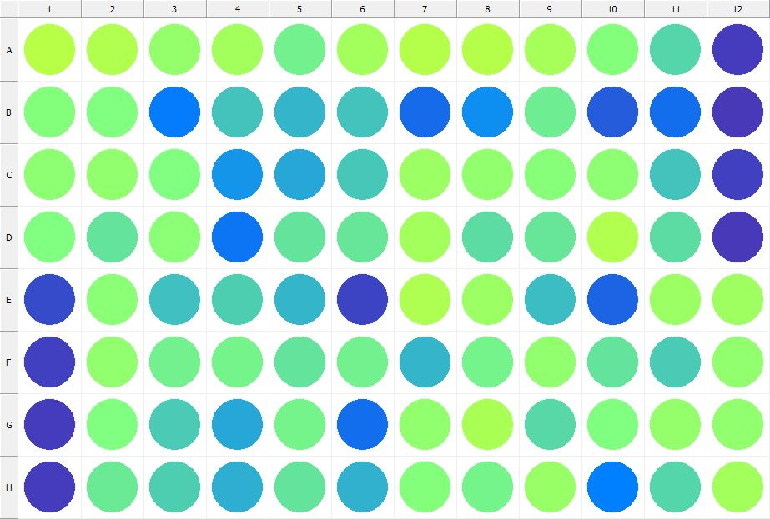

|  |
| --- |
| **Results for Tim_CTB(1) - channel 1 (RFU) - Plate information/ Compound at 2 uM + DMSO_R2** |

|  |  |  |  |  |  |  |  |  |  |  |  |  |
| --- | --- | --- | --- | --- | --- | --- | --- | --- | --- | --- | --- | --- |
|  | 01 | 02 | 03 | 04 | 05 | 06 | 07 | 08 | 09 | 10 | 11 | 12 |
| A | 207172 | 202482 | 183606 | 193432 | 158236 | 192132 | 203934 | 204622 | 193908 | 170044 | 139512 | 35334 |
| B | 171713 | 167561 | 79191 | 126512 | 117618 | 128456 | 67346 | 90586 | 156717 | 58807 | 70684 | 34384 |
| C | 177701 | 180366 | 168339 | 96650 | 108387 | 130751 | 188199 | 180578 | 172729 | 178199 | 128156 | 39103 |
| D | 169532 | 149363 | 176127 | 75844 | 149523 | 152721 | 193861 | 145117 | 150890 | 201964 | 143859 | 34490 |
| E | 46278 | 175940 | 124616 | 134134 | 118017 | 40273 | 200892 | 187765 | 122835 | 63686 | 188983 | 190441 |
| F | 39361 | 181454 | 158673 | 161947 | 149634 | 158789 | 119195 | 162235 | 180226 | 150009 | 132128 | 181194 |
| G | 37149 | 169028 | 132422 | 108449 | 162538 | 69419 | 181779 | 198654 | 141807 | 167896 | 183443 | 181140 |
| H | 35140 | 153156 | 135169 | 112945 | 149710 | 115748 | 170620 | 160409 | 185076 | 81937 | 140862 | 192417 |

|  |  |
| --- | --- |
| **Plate information** | |
|  | |
| **Plate** | 2 |
| **Repeat** | 1 |
| **Barcode** |  |
| **Measured height** | 14.78 |
| **Inside temperature at start** | 23.25 |
| **Inside temperature at end** | 23.27 |
| **Humidity at start** | 21.4 |
| **Humidity at end** | 21.5 |
| **Ambient temperature at start** | 23.44 |
| **Ambient temperature at end** | 23.36 |
| **Group** | 1 |
| **Label** | Tim_CTB(1) |
| **ScanX** | 0 |
| **ScanY** | 0 |
| **Measinfo** | De=1st Ex=Top Em=Top Wdw=N/A (14) |
| **Kinetics** | 0 |
| **Measurement date** | 11/14/2022 2:46:18 PM |
|  | |

|  |
| --- |
| **Background information** |
| Legend:  HDR1 - Plate  HDR2 - Label  HDR3 - Result  HDR4 - Signal  HDR5 - Flashes/Time  HDR6 - Meastime  HDR7 - MeasInfo |
| HDR1 HDR2 HDR3 HDR4 HDR5 HDR6 HDR7  2 Tim_CTB 0 1052 1 00:00:00.000 De=1st Ex=Top Em=Top Wdw=N/A (14) |
|  |

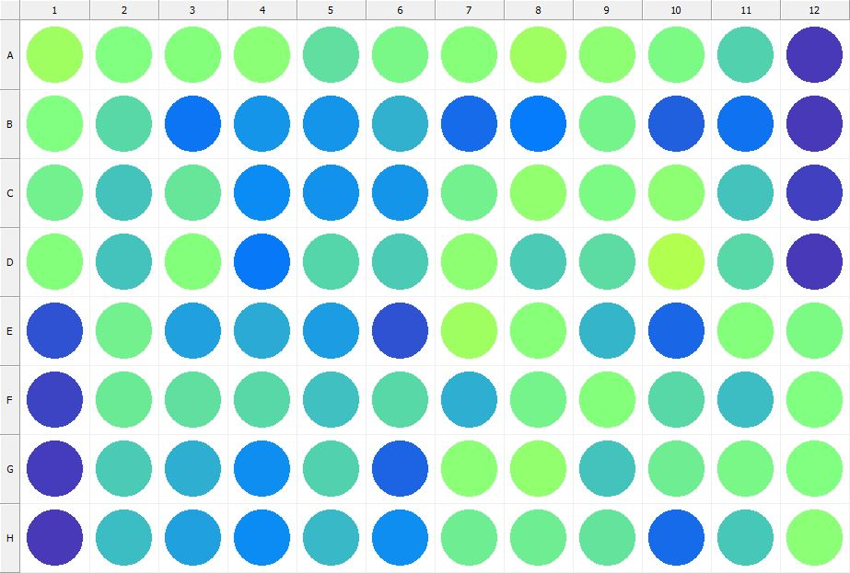

|  |
| --- |
| **Results for Tim_CTB(1) - channel 1 (RFU) - Plate information/ Compound at 2 uM + DMSO_R3** |

|  |  |  |  |  |  |  |  |  |  |  |  |  |
| --- | --- | --- | --- | --- | --- | --- | --- | --- | --- | --- | --- | --- |
|  | 01 | 02 | 03 | 04 | 05 | 06 | 07 | 08 | 09 | 10 | 11 | 12 |
| A | 189371 | 168269 | 170065 | 176097 | 146240 | 164812 | 173805 | 190613 | 178700 | 165676 | 136976 | 34333 |
| B | 167713 | 142052 | 74418 | 96525 | 95625 | 115608 | 67041 | 79273 | 160590 | 59020 | 71954 | 34469 |
| C | 158570 | 126989 | 152777 | 89106 | 94716 | 95708 | 158935 | 180329 | 165722 | 177930 | 127058 | 39039 |
| D | 170331 | 126664 | 171092 | 77910 | 140165 | 132940 | 179284 | 131527 | 143330 | 201653 | 142881 | 34077 |
| E | 49455 | 159295 | 102472 | 109684 | 100763 | 50902 | 189699 | 174116 | 117496 | 65017 | 170034 | 167251 |
| F | 40841 | 155181 | 147817 | 142925 | 125035 | 141787 | 112288 | 161007 | 171440 | 142605 | 122724 | 169344 |
| G | 37074 | 132746 | 113687 | 92662 | 138010 | 63803 | 175111 | 181643 | 127478 | 155497 | 164549 | 169753 |
| H | 33640 | 122425 | 103269 | 89661 | 119679 | 90888 | 156725 | 155787 | 148312 | 66645 | 130054 | 175712 |

|  |  |
| --- | --- |
| **Plate information** | |
|  | |
| **Plate** | 3 |
| **Repeat** | 1 |
| **Barcode** |  |
| **Measured height** | 14.78 |
| **Inside temperature at start** | 23.25 |
| **Inside temperature at end** | 23.27 |
| **Humidity at start** | 21.5 |
| **Humidity at end** | 21.5 |
| **Ambient temperature at start** | 23.34 |
| **Ambient temperature at end** | 23.27 |
| **Group** | 1 |
| **Label** | Tim_CTB(1) |
| **ScanX** | 0 |
| **ScanY** | 0 |
| **Measinfo** | De=1st Ex=Top Em=Top Wdw=N/A (14) |
| **Kinetics** | 0 |
| **Measurement date** | 11/14/2022 2:46:57 PM |
|  | |

|  |
| --- |
| **Background information** |
| Legend:  HDR1 - Plate  HDR2 - Label  HDR3 - Result  HDR4 - Signal  HDR5 - Flashes/Time  HDR6 - Meastime  HDR7 - MeasInfo |
| HDR1 HDR2 HDR3 HDR4 HDR5 HDR6 HDR7  3 Tim_CTB 0 1043 1 00:00:00.000 De=1st Ex=Top Em=Top Wdw=N/A (14) |
|  |

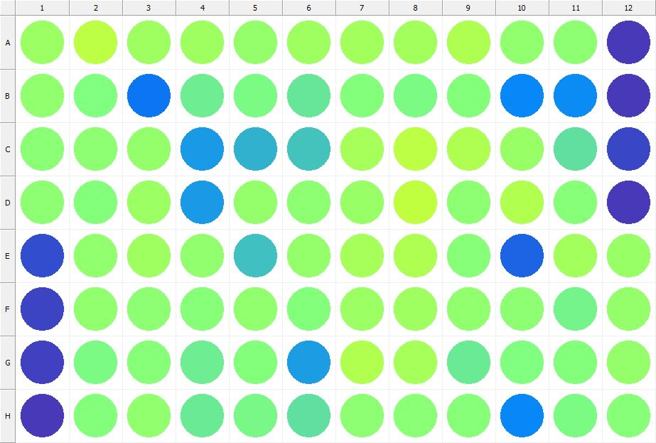

|  |
| --- |
| **Results for Tim_CTB(1) - channel 1 (RFU) - Plate information/ Compound at 200 NM + DMSO_R1** |

|  |  |  |  |  |  |  |  |  |  |  |  |  |
| --- | --- | --- | --- | --- | --- | --- | --- | --- | --- | --- | --- | --- |
|  | 01 | 02 | 03 | 04 | 05 | 06 | 07 | 08 | 09 | 10 | 11 | 12 |
| A | 187476 | 208367 | 189689 | 190331 | 182310 | 191321 | 192455 | 193756 | 200074 | 179843 | 179424 | 33921 |
| B | 180030 | 168216 | 74818 | 157627 | 165192 | 152270 | 171082 | 166598 | 170190 | 87880 | 88178 | 34366 |
| C | 175231 | 177538 | 184011 | 98506 | 115930 | 128189 | 195328 | 209795 | 199635 | 184453 | 146419 | 42225 |
| D | 178552 | 171517 | 187400 | 97788 | 182064 | 178038 | 184261 | 212336 | 178675 | 201859 | 172290 | 34163 |
| E | 47754 | 179535 | 190482 | 180120 | 125289 | 183513 | 196231 | 200085 | 172443 | 63267 | 191977 | 185378 |
| F | 40579 | 181030 | 179375 | 174606 | 181165 | 171389 | 187329 | 190403 | 180925 | 178269 | 161394 | 182127 |
| G | 38208 | 166938 | 173317 | 156146 | 170515 | 101400 | 203074 | 194422 | 153153 | 167491 | 171558 | 182233 |
| H | 34763 | 171426 | 180190 | 154086 | 163403 | 147977 | 178848 | 175363 | 172370 | 86297 | 166970 | 173358 |

|  |  |
| --- | --- |
| **Plate information** | |
|  | |
| **Plate** | 4 |
| **Repeat** | 1 |
| **Barcode** |  |
| **Measured height** | 14.78 |
| **Inside temperature at start** | 23.34 |
| **Inside temperature at end** | 23.36 |
| **Humidity at start** | 21.1 |
| **Humidity at end** | 21.4 |
| **Ambient temperature at start** | 23.34 |
| **Ambient temperature at end** | 23.46 |
| **Group** | 1 |
| **Label** | Tim_CTB(1) |
| **ScanX** | 0 |
| **ScanY** | 0 |
| **Measinfo** | De=1st Ex=Top Em=Top Wdw=N/A (14) |
| **Kinetics** | 0 |
| **Measurement date** | 11/14/2022 2:47:37 PM |
|  | |

|  |
| --- |
| **Background information** |
| Legend:  HDR1 - Plate  HDR2 - Label  HDR3 - Result  HDR4 - Signal  HDR5 - Flashes/Time  HDR6 - Meastime  HDR7 - MeasInfo |
| HDR1 HDR2 HDR3 HDR4 HDR5 HDR6 HDR7  4 Tim_CTB 0 1030 1 00:00:00.000 De=1st Ex=Top Em=Top Wdw=N/A (14) |
|  |

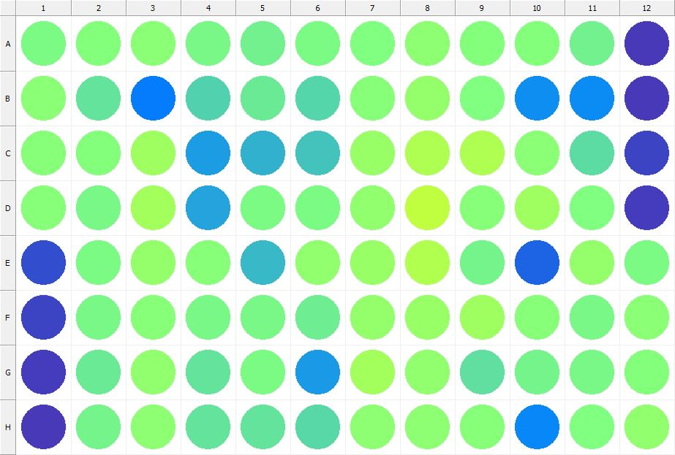

|  |
| --- |
| **Results for Tim_CTB(1) - channel 1 (RFU) - Plate information/ Compound at 200 nM + DMSO_R2** |

|  |  |  |  |  |  |  |  |  |  |  |  |  |
| --- | --- | --- | --- | --- | --- | --- | --- | --- | --- | --- | --- | --- |
|  | 01 | 02 | 03 | 04 | 05 | 06 | 07 | 08 | 09 | 10 | 11 | 12 |
| A | 165736 | 170074 | 175727 | 163044 | 160138 | 165233 | 169686 | 178297 | 172186 | 171498 | 159817 | 34544 |
| B | 174981 | 150374 | 79816 | 137557 | 154039 | 139891 | 172221 | 182355 | 169440 | 90639 | 88702 | 34718 |
| C | 173246 | 170823 | 191082 | 100154 | 115757 | 126785 | 186177 | 200125 | 200480 | 176897 | 144696 | 41711 |
| D | 173551 | 164691 | 193524 | 105147 | 165199 | 165324 | 181170 | 211562 | 173513 | 190998 | 167776 | 35535 |
| E | 48415 | 166055 | 183504 | 173649 | 121035 | 180496 | 185707 | 203013 | 161334 | 63209 | 182151 | 166978 |
| F | 40700 | 162929 | 172562 | 163851 | 163994 | 156783 | 182839 | 185753 | 189499 | 172290 | 163886 | 176932 |
| G | 37092 | 154728 | 179598 | 149088 | 165372 | 99418 | 193008 | 180913 | 147359 | 160265 | 164404 | 170433 |
| H | 34194 | 161906 | 179130 | 149625 | 150498 | 142371 | 179015 | 179253 | 173826 | 87202 | 168796 | 180175 |

|  |  |
| --- | --- |
| **Plate information** | |
|  | |
| **Plate** | 5 |
| **Repeat** | 1 |
| **Barcode** |  |
| **Measured height** | 14.78 |
| **Inside temperature at start** | 23.34 |
| **Inside temperature at end** | 23.34 |
| **Humidity at start** | 21.4 |
| **Humidity at end** | 21.4 |
| **Ambient temperature at start** | 23.25 |
| **Ambient temperature at end** | 23.25 |
| **Group** | 1 |
| **Label** | Tim_CTB(1) |
| **ScanX** | 0 |
| **ScanY** | 0 |
| **Measinfo** | De=1st Ex=Top Em=Top Wdw=N/A (14) |
| **Kinetics** | 0 |
| **Measurement date** | 11/14/2022 2:48:19 PM |
|  | |

|  |
| --- |
| **Background information** |
| Legend:  HDR1 - Plate  HDR2 - Label  HDR3 - Result  HDR4 - Signal  HDR5 - Flashes/Time  HDR6 - Meastime  HDR7 - MeasInfo |
| HDR1 HDR2 HDR3 HDR4 HDR5 HDR6 HDR7  5 Tim_CTB 0 1088 1 00:00:00.000 De=1st Ex=Top Em=Top Wdw=N/A (14) |
|  |

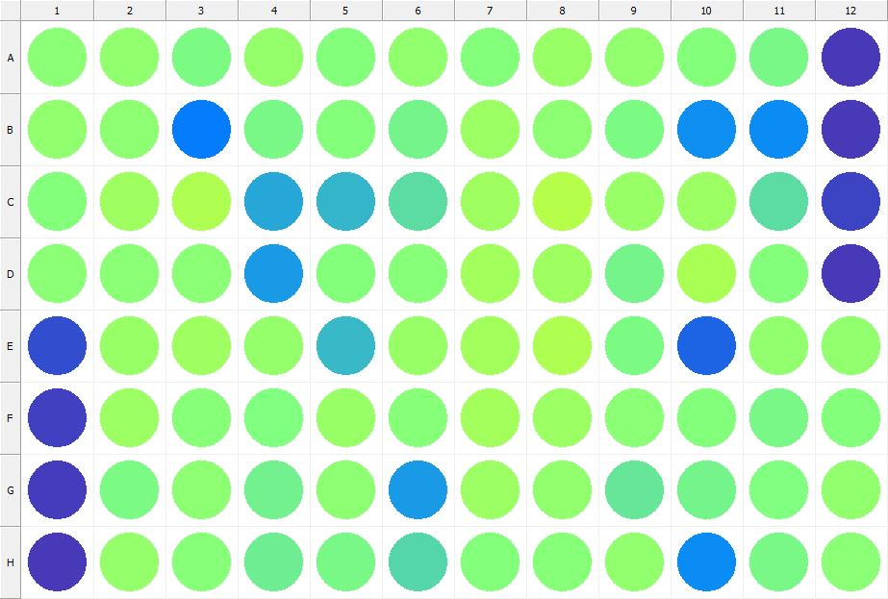

|  |
| --- |
| **Results for Tim_CTB(1) - channel 1 (RFU) - Plate information/ Compound at 200 nM + DMSO_R3** |

|  |  |  |  |  |  |  |  |  |  |  |  |  |
| --- | --- | --- | --- | --- | --- | --- | --- | --- | --- | --- | --- | --- |
|  | 01 | 02 | 03 | 04 | 05 | 06 | 07 | 08 | 09 | 10 | 11 | 12 |
| A | 175514 | 180246 | 166596 | 183494 | 170208 | 180893 | 171466 | 185629 | 179612 | 171939 | 164666 | 33738 |
| B | 179563 | 178240 | 80331 | 163631 | 170012 | 162402 | 188105 | 177847 | 167150 | 90410 | 88704 | 32902 |
| C | 169937 | 190158 | 198990 | 108030 | 118042 | 144278 | 189368 | 205078 | 186627 | 186931 | 143762 | 41231 |
| D | 176698 | 176160 | 175461 | 99506 | 170646 | 174498 | 191538 | 191175 | 162453 | 198601 | 172153 | 34700 |
| E | 47983 | 186594 | 190477 | 182118 | 120472 | 184697 | 191708 | 198938 | 165004 | 62764 | 180433 | 179813 |
| F | 38232 | 186762 | 173968 | 168904 | 185261 | 172937 | 193005 | 188414 | 175910 | 170169 | 164874 | 171235 |
| G | 35720 | 166535 | 178038 | 159240 | 177654 | 98578 | 187309 | 179503 | 152321 | 162243 | 169392 | 181813 |
| H | 34385 | 181983 | 173883 | 156424 | 164007 | 139171 | 170703 | 174174 | 179889 | 88835 | 163786 | 175052 |

|  |  |
| --- | --- |
| **Plate information** | |
|  | |
| **Plate** | 6 |
| **Repeat** | 1 |
| **Barcode** |  |
| **Measured height** | 14.78 |
| **Inside temperature at start** | 23.34 |
| **Inside temperature at end** | 23.34 |
| **Humidity at start** | 21.2 |
| **Humidity at end** | 21.2 |
| **Ambient temperature at start** | 23.34 |
| **Ambient temperature at end** | 23.34 |
| **Group** | 1 |
| **Label** | Tim_CTB(1) |
| **ScanX** | 0 |
| **ScanY** | 0 |
| **Measinfo** | De=1st Ex=Top Em=Top Wdw=N/A (14) |
| **Kinetics** | 0 |
| **Measurement date** | 11/14/2022 2:48:59 PM |
|  | |

|  |
| --- |
| **Background information** |
| Legend:  HDR1 - Plate  HDR2 - Label  HDR3 - Result  HDR4 - Signal  HDR5 - Flashes/Time  HDR6 - Meastime  HDR7 - MeasInfo |
| HDR1 HDR2 HDR3 HDR4 HDR5 HDR6 HDR7  6 Tim_CTB 0 1131 1 00:00:00.000 De=1st Ex=Top Em=Top Wdw=N/A (14) |
|  |

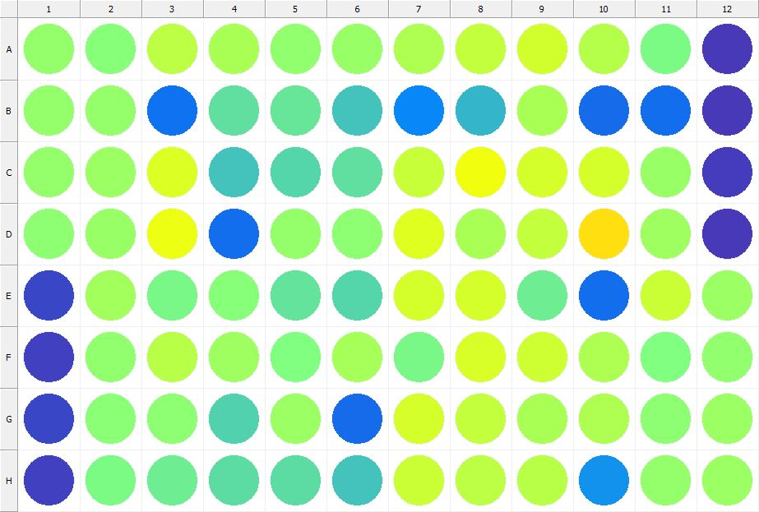

|  |
| --- |
| **Results for Tim_CTB(1) - channel 1 (RFU) - Plate information/ Compound at 2 uM + CBD_R1** |

|  |  |  |  |  |  |  |  |  |  |  |  |  |
| --- | --- | --- | --- | --- | --- | --- | --- | --- | --- | --- | --- | --- |
|  | 01 | 02 | 03 | 04 | 05 | 06 | 07 | 08 | 09 | 10 | 11 | 12 |
| A | 183955 | 174386 | 209217 | 197165 | 181420 | 185590 | 198788 | 214952 | 224353 | 204498 | 165382 | 34226 |
| B | 182796 | 183035 | 72413 | 146266 | 150549 | 127037 | 86064 | 118532 | 198608 | 67632 | 70936 | 33208 |
| C | 182328 | 189042 | 230758 | 128308 | 138751 | 147242 | 217970 | 245522 | 225350 | 226611 | 185292 | 36194 |
| D | 177129 | 184763 | 242870 | 70149 | 183421 | 179296 | 233570 | 198058 | 215511 | 276197 | 190171 | 34481 |
| E | 42617 | 192596 | 163371 | 173792 | 148872 | 139554 | 227044 | 226170 | 156315 | 70155 | 220336 | 187560 |
| F | 37923 | 181134 | 206812 | 190747 | 168422 | 196002 | 163289 | 228064 | 220962 | 199856 | 169328 | 181482 |
| G | 42901 | 175581 | 178266 | 136842 | 186802 | 68105 | 226294 | 215343 | 197984 | 201054 | 178346 | 187486 |
| H | 38069 | 167397 | 155371 | 145002 | 143920 | 126476 | 219707 | 210379 | 207036 | 93767 | 183763 | 186816 |

|  |  |
| --- | --- |
| **Plate information** | |
|  | |
| **Plate** | 7 |
| **Repeat** | 1 |
| **Barcode** |  |
| **Measured height** | 14.78 |
| **Inside temperature at start** | 23.34 |
| **Inside temperature at end** | 23.34 |
| **Humidity at start** | 21.2 |
| **Humidity at end** | 21.2 |
| **Ambient temperature at start** | 23.34 |
| **Ambient temperature at end** | 23.34 |
| **Group** | 1 |
| **Label** | Tim_CTB(1) |
| **ScanX** | 0 |
| **ScanY** | 0 |
| **Measinfo** | De=1st Ex=Top Em=Top Wdw=N/A (14) |
| **Kinetics** | 0 |
| **Measurement date** | 11/14/2022 2:50:11 PM |
|  | |

|  |
| --- |
| **Background information** |
| Legend:  HDR1 - Plate  HDR2 - Label  HDR3 - Result  HDR4 - Signal  HDR5 - Flashes/Time  HDR6 - Meastime  HDR7 - MeasInfo |
| HDR1 HDR2 HDR3 HDR4 HDR5 HDR6 HDR7  7 Tim_CTB 0 1201 1 00:00:00.000 De=1st Ex=Top Em=Top Wdw=N/A (14) |
|  |

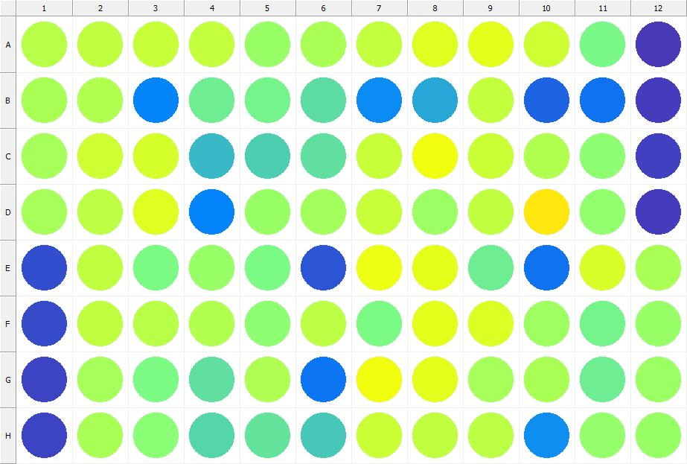

|  |
| --- |
| **Results for Tim_CTB(1) - channel 1 (RFU) - Plate information/ Compound at 2 uM + CBD_R2** |

|  |  |  |  |  |  |  |  |  |  |  |  |  |
| --- | --- | --- | --- | --- | --- | --- | --- | --- | --- | --- | --- | --- |
|  | 01 | 02 | 03 | 04 | 05 | 06 | 07 | 08 | 09 | 10 | 11 | 12 |
| A | 206071 | 211343 | 216727 | 213407 | 185972 | 197800 | 213468 | 234545 | 236426 | 221321 | 163573 | 34453 |
| B | 197648 | 203379 | 84536 | 157763 | 161422 | 143500 | 89152 | 108488 | 214985 | 63827 | 73195 | 35065 |
| C | 194653 | 221716 | 225614 | 120750 | 133859 | 146103 | 217146 | 245946 | 219048 | 202719 | 177618 | 39284 |
| D | 193994 | 208954 | 232814 | 84639 | 185759 | 191751 | 216706 | 188588 | 211173 | 271647 | 180302 | 35435 |
| E | 47261 | 212598 | 165210 | 184685 | 166910 | 53043 | 243102 | 238835 | 155610 | 71228 | 228538 | 197576 |
| F | 45227 | 211393 | 206986 | 201264 | 177897 | 209035 | 166010 | 234848 | 230981 | 191298 | 161281 | 185433 |
| G | 41883 | 195094 | 166320 | 147606 | 198847 | 74369 | 246478 | 236894 | 194261 | 196799 | 157215 | 187380 |
| H | 40129 | 197990 | 174923 | 139173 | 148216 | 130323 | 218642 | 212983 | 209951 | 92399 | 184124 | 185800 |

|  |  |
| --- | --- |
| **Plate information** | |
|  | |
| **Plate** | 8 |
| **Repeat** | 1 |
| **Barcode** |  |
| **Measured height** | 14.78 |
| **Inside temperature at start** | 23.34 |
| **Inside temperature at end** | 23.34 |
| **Humidity at start** | 21.2 |
| **Humidity at end** | 21.2 |
| **Ambient temperature at start** | 23.34 |
| **Ambient temperature at end** | 23.25 |
| **Group** | 1 |
| **Label** | Tim_CTB(1) |
| **ScanX** | 0 |
| **ScanY** | 0 |
| **Measinfo** | De=1st Ex=Top Em=Top Wdw=N/A (14) |
| **Kinetics** | 0 |
| **Measurement date** | 11/14/2022 2:50:56 PM |
|  | |

|  |
| --- |
| **Background information** |
| Legend:  HDR1 - Plate  HDR2 - Label  HDR3 - Result  HDR4 - Signal  HDR5 - Flashes/Time  HDR6 - Meastime  HDR7 - MeasInfo |
| HDR1 HDR2 HDR3 HDR4 HDR5 HDR6 HDR7  8 Tim_CTB 0 953 1 00:00:00.000 De=1st Ex=Top Em=Top Wdw=N/A (14) |
|  |

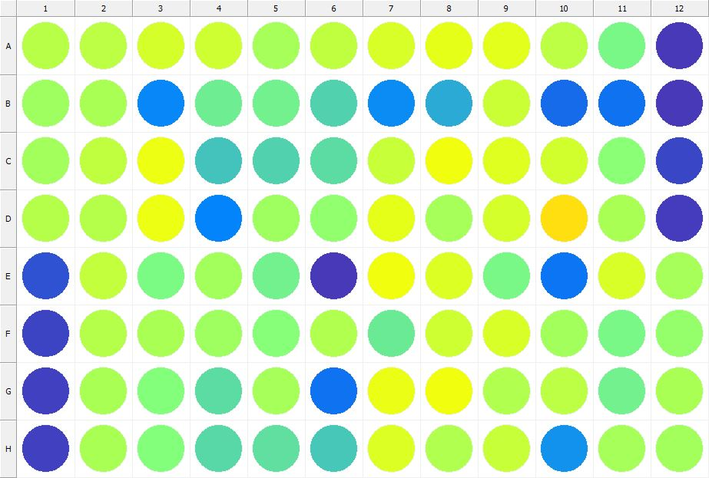

|  |
| --- |
| **Results for Tim_CTB(1) - channel 1 (RFU) - Plate information/ Compound at 2 uM + CBD_R3** |

|  |  |  |  |  |  |  |  |  |  |  |  |  |
| --- | --- | --- | --- | --- | --- | --- | --- | --- | --- | --- | --- | --- |
|  | 01 | 02 | 03 | 04 | 05 | 06 | 07 | 08 | 09 | 10 | 11 | 12 |
| A | 206042 | 208742 | 226497 | 221129 | 194522 | 211552 | 228325 | 237509 | 236235 | 210331 | 164822 | 34907 |
| B | 190314 | 198387 | 85860 | 156422 | 159056 | 136739 | 88841 | 110933 | 219686 | 67887 | 73230 | 34284 |
| C | 192443 | 213077 | 242206 | 127616 | 136509 | 143669 | 216739 | 246262 | 233343 | 224272 | 175531 | 42710 |
| D | 204026 | 205812 | 244318 | 83199 | 189648 | 180294 | 237895 | 196018 | 226605 | 275839 | 198164 | 35334 |
| E | 50404 | 214532 | 165117 | 192086 | 157783 | 34308 | 245876 | 232237 | 164515 | 74217 | 227944 | 194295 |
| F | 41491 | 205184 | 197532 | 190463 | 172236 | 202068 | 153894 | 221828 | 229437 | 193159 | 163916 | 183553 |
| G | 38800 | 196552 | 170708 | 143334 | 196044 | 72129 | 240486 | 244752 | 202967 | 209463 | 160006 | 197136 |
| H | 38860 | 198113 | 171251 | 141886 | 146421 | 129011 | 231650 | 201869 | 216071 | 93238 | 195106 | 191869 |

|  |  |
| --- | --- |
| **Plate information** | |
|  | |
| **Plate** | 9 |
| **Repeat** | 1 |
| **Barcode** |  |
| **Measured height** | 14.78 |
| **Inside temperature at start** | 23.34 |
| **Inside temperature at end** | 23.34 |
| **Humidity at start** | 21.4 |
| **Humidity at end** | 21.4 |
| **Ambient temperature at start** | 23.25 |
| **Ambient temperature at end** | 23.34 |
| **Group** | 1 |
| **Label** | Tim_CTB(1) |
| **ScanX** | 0 |
| **ScanY** | 0 |
| **Measinfo** | De=1st Ex=Top Em=Top Wdw=N/A (14) |
| **Kinetics** | 0 |
| **Measurement date** | 11/14/2022 2:51:39 PM |
|  | |

|  |
| --- |
| **Background information** |
| Legend:  HDR1 - Plate  HDR2 - Label  HDR3 - Result  HDR4 - Signal  HDR5 - Flashes/Time  HDR6 - Meastime  HDR7 - MeasInfo |
| HDR1 HDR2 HDR3 HDR4 HDR5 HDR6 HDR7  9 Tim_CTB 0 1034 1 00:00:00.000 De=1st Ex=Top Em=Top Wdw=N/A (14) |
|  |

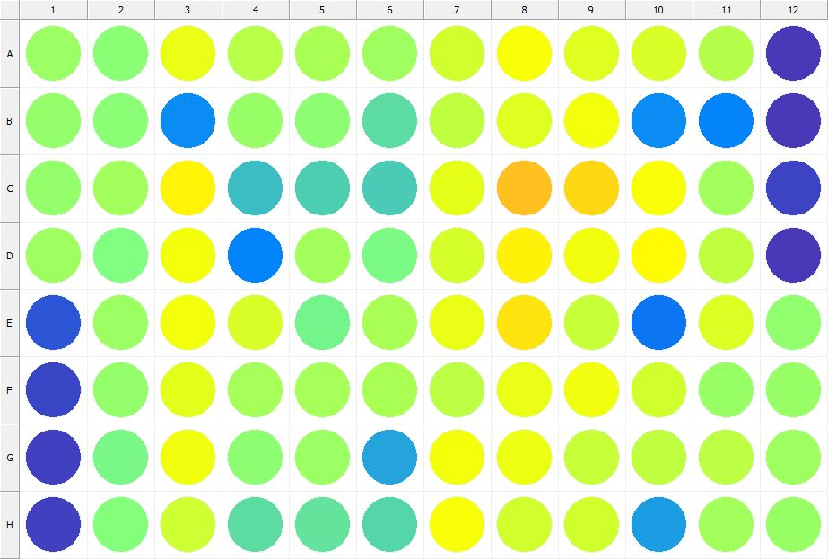

|  |
| --- |
| **Results for Tim_CTB(1) - channel 1 (RFU) - Plate information/ Compound at 200 nM + CBD_R1** |

|  |  |  |  |  |  |  |  |  |  |  |  |  |
| --- | --- | --- | --- | --- | --- | --- | --- | --- | --- | --- | --- | --- |
|  | 01 | 02 | 03 | 04 | 05 | 06 | 07 | 08 | 09 | 10 | 11 | 12 |
| A | 188604 | 176091 | 240021 | 207951 | 197767 | 190892 | 224475 | 251351 | 233782 | 228641 | 205305 | 33583 |
| B | 183007 | 177012 | 89487 | 184308 | 178886 | 143398 | 211288 | 234279 | 249271 | 89164 | 84256 | 34537 |
| C | 182130 | 193535 | 262970 | 123400 | 135856 | 131360 | 238753 | 298612 | 282117 | 250606 | 192187 | 41354 |
| D | 190094 | 168235 | 247006 | 84035 | 192374 | 167284 | 226767 | 265648 | 245162 | 257231 | 212400 | 34323 |
| E | 51914 | 187342 | 248913 | 228373 | 161095 | 196686 | 241316 | 273668 | 216804 | 74136 | 230118 | 181597 |
| F | 42749 | 183145 | 235385 | 196039 | 194968 | 197679 | 209557 | 240024 | 245564 | 223464 | 186507 | 185204 |
| G | 38162 | 164478 | 246798 | 179325 | 187751 | 106688 | 247294 | 243952 | 217207 | 211670 | 210529 | 189788 |
| H | 38421 | 169983 | 221466 | 143889 | 149581 | 139051 | 251501 | 223222 | 223886 | 101570 | 193616 | 184784 |

|  |  |
| --- | --- |
| **Plate information** | |
|  | |
| **Plate** | 10 |
| **Repeat** | 1 |
| **Barcode** |  |
| **Measured height** | 14.78 |
| **Inside temperature at start** | 23.44 |
| **Inside temperature at end** | 23.46 |
| **Humidity at start** | 20.9 |
| **Humidity at end** | 20.9 |
| **Ambient temperature at start** | 23.44 |
| **Ambient temperature at end** | 23.46 |
| **Group** | 1 |
| **Label** | Tim_CTB(1) |
| **ScanX** | 0 |
| **ScanY** | 0 |
| **Measinfo** | De=1st Ex=Top Em=Top Wdw=N/A (14) |
| **Kinetics** | 0 |
| **Measurement date** | 11/14/2022 2:52:20 PM |
|  | |

|  |
| --- |
| **Background information** |
| Legend:  HDR1 - Plate  HDR2 - Label  HDR3 - Result  HDR4 - Signal  HDR5 - Flashes/Time  HDR6 - Meastime  HDR7 - MeasInfo |
| HDR1 HDR2 HDR3 HDR4 HDR5 HDR6 HDR7  10 Tim_CTB 0 1116 1 00:00:00.000 De=1st Ex=Top Em=Top Wdw=N/A (14) |
|  |

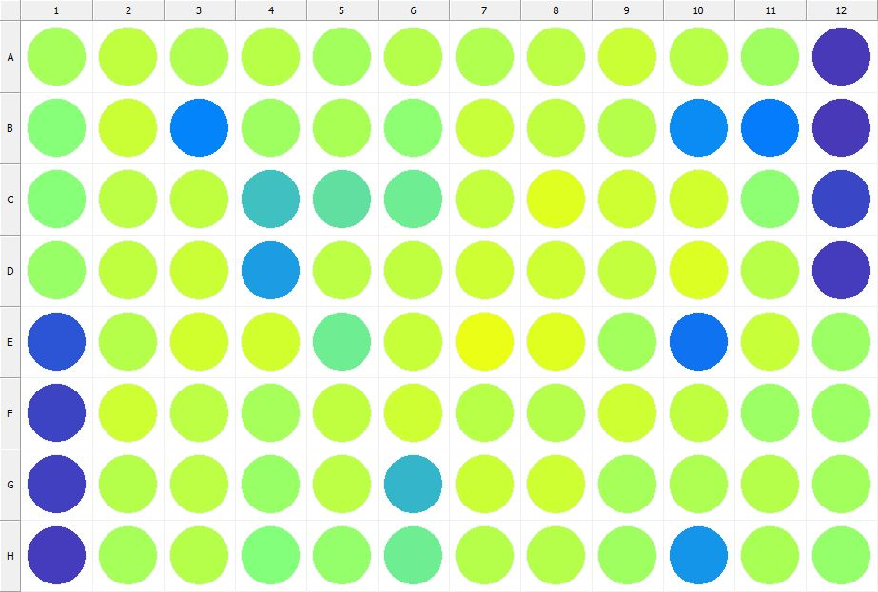

|  |
| --- |
| **Results for Tim_CTB(1) - channel 1 (RFU) - Plate information/ Compound at 200 nM + CBD_R2** |

|  |  |  |  |  |  |  |  |  |  |  |  |  |
| --- | --- | --- | --- | --- | --- | --- | --- | --- | --- | --- | --- | --- |
|  | 01 | 02 | 03 | 04 | 05 | 06 | 07 | 08 | 09 | 10 | 11 | 12 |
| A | 193893 | 212160 | 201166 | 206153 | 192472 | 204917 | 202589 | 210548 | 218609 | 207461 | 190844 | 34538 |
| B | 172871 | 218293 | 85030 | 189380 | 197157 | 177060 | 216150 | 213149 | 204798 | 90210 | 78861 | 34420 |
| C | 173945 | 210676 | 212159 | 126389 | 146384 | 156158 | 215332 | 233072 | 221357 | 224068 | 179203 | 43789 |
| D | 185485 | 212066 | 218000 | 101694 | 209485 | 211799 | 222154 | 220811 | 214011 | 231192 | 207061 | 35924 |
| E | 52294 | 204020 | 224427 | 224669 | 156251 | 215908 | 242000 | 233789 | 192670 | 72652 | 217223 | 187958 |
| F | 42001 | 221642 | 210341 | 194604 | 211404 | 221143 | 206011 | 205062 | 221183 | 212200 | 188205 | 187046 |
| G | 39528 | 204294 | 209051 | 186438 | 210116 | 118848 | 220238 | 220394 | 195919 | 199653 | 205683 | 191583 |
| H | 36913 | 195936 | 205106 | 172092 | 182796 | 155776 | 204681 | 205053 | 191149 | 96362 | 198513 | 183282 |

|  |  |
| --- | --- |
| **Plate information** | |
|  | |
| **Plate** | 11 |
| **Repeat** | 1 |
| **Barcode** |  |
| **Measured height** | 14.78 |
| **Inside temperature at start** | 23.44 |
| **Inside temperature at end** | 23.44 |
| **Humidity at start** | 21.1 |
| **Humidity at end** | 21.1 |
| **Ambient temperature at start** | 23.44 |
| **Ambient temperature at end** | 23.54 |
| **Group** | 1 |
| **Label** | Tim_CTB(1) |
| **ScanX** | 0 |
| **ScanY** | 0 |
| **Measinfo** | De=1st Ex=Top Em=Top Wdw=N/A (14) |
| **Kinetics** | 0 |
| **Measurement date** | 11/14/2022 2:53:08 PM |
|  | |

|  |
| --- |
| **Background information** |
| Legend:  HDR1 - Plate  HDR2 - Label  HDR3 - Result  HDR4 - Signal  HDR5 - Flashes/Time  HDR6 - Meastime  HDR7 - MeasInfo |
| HDR1 HDR2 HDR3 HDR4 HDR5 HDR6 HDR7  11 Tim_CTB 0 1004 1 00:00:00.000 De=1st Ex=Top Em=Top Wdw=N/A (14) |
|  |

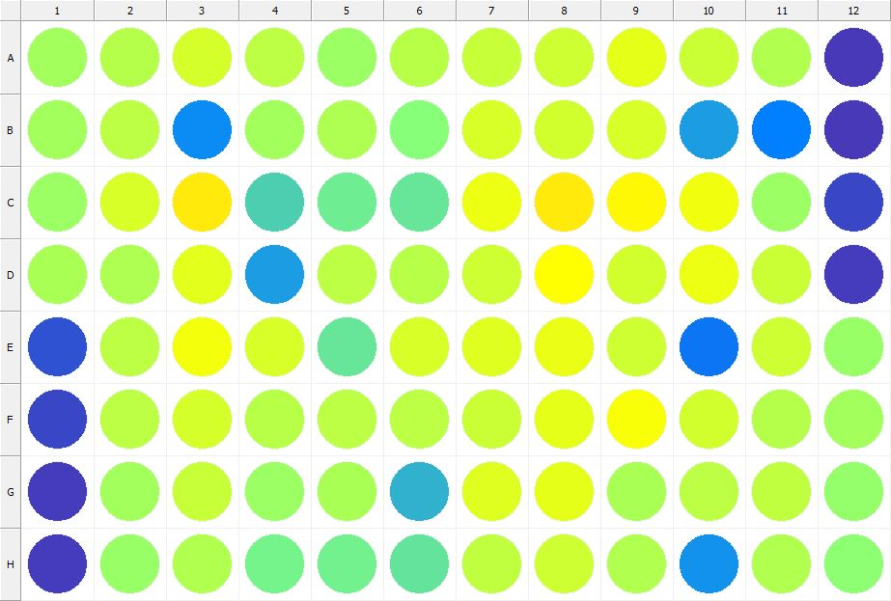

|  |
| --- |
| **Results for Tim_CTB(1) - channel 1 (RFU) - Plate information/ Compound at 200 nM + CBD_R3** |

|  |  |  |  |  |  |  |  |  |  |  |  |  |
| --- | --- | --- | --- | --- | --- | --- | --- | --- | --- | --- | --- | --- |
|  | 01 | 02 | 03 | 04 | 05 | 06 | 07 | 08 | 09 | 10 | 11 | 12 |
| A | 192789 | 203727 | 227193 | 209297 | 188407 | 206071 | 215625 | 220847 | 238036 | 218146 | 201648 | 34274 |
| B | 191576 | 208994 | 89006 | 192195 | 200918 | 172738 | 229213 | 224592 | 229364 | 101798 | 80700 | 34076 |
| C | 187524 | 229048 | 268986 | 135654 | 157250 | 152943 | 243962 | 268998 | 259586 | 244856 | 187103 | 42890 |
| D | 196704 | 200253 | 236836 | 101300 | 210505 | 207352 | 222073 | 254884 | 224135 | 244046 | 220016 | 35079 |
| E | 49704 | 209678 | 247619 | 228915 | 152764 | 228229 | 233911 | 241297 | 221678 | 75447 | 221261 | 186597 |
| F | 42690 | 209179 | 227050 | 207376 | 208561 | 209926 | 219349 | 238885 | 249307 | 223233 | 203684 | 192326 |
| G | 36332 | 193455 | 217768 | 186942 | 197977 | 114436 | 233301 | 238977 | 196434 | 210741 | 210761 | 183513 |
| H | 35332 | 186049 | 202320 | 160673 | 160064 | 150299 | 211421 | 221774 | 202218 | 95098 | 201242 | 179134 |

|  |  |
| --- | --- |
| **Plate information** | |
|  | |
| **Plate** | 12 |
| **Repeat** | 1 |
| **Barcode** |  |
| **Measured height** | 14.78 |
| **Inside temperature at start** | 23.54 |
| **Inside temperature at end** | 23.54 |
| **Humidity at start** | 20.9 |
| **Humidity at end** | 20.9 |
| **Ambient temperature at start** | 23.73 |
| **Ambient temperature at end** | 23.73 |
| **Group** | 1 |
| **Label** | Tim_CTB(1) |
| **ScanX** | 0 |
| **ScanY** | 0 |
| **Measinfo** | De=1st Ex=Top Em=Top Wdw=N/A (14) |
| **Kinetics** | 0 |
| **Measurement date** | 11/14/2022 2:53:50 PM |
|  | |

|  |
| --- |
| **Background information** |
| Legend:  HDR1 - Plate  HDR2 - Label  HDR3 - Result  HDR4 - Signal  HDR5 - Flashes/Time  HDR6 - Meastime  HDR7 - MeasInfo |
| HDR1 HDR2 HDR3 HDR4 HDR5 HDR6 HDR7  12 Tim_CTB 0 959 1 00:00:00.000 De=1st Ex=Top Em=Top Wdw=N/A (14) |
|  |

|  |  |
| --- | --- |
|  | |
| **Basic assay information** | |
| **Assay ID** | 24191 |
| **Assay Started** | 11/14/2022 2:45:22 PM |
| **Assay Finished** | 11/14/2022 2:54:12 PM |
| **Assay Exported** | 11/14/2022 2:57:43 PM |
| **Protocol ID** | 100568 |
| **Protocol Name** | Copy of 96well-CTB_Tim |
| **Serial#** | 1020141 |
|  | |
|  | |
|  | |
| **Protocol information** | |
| **Protocol:** | |
| **Protocol name** | Copy of 96well-CTB_Tim |
| **Number of assay repeats** | 1 |
| **Start assay repeat each** | N/A |
| **Number of plate repeats** | 1 |
| **Start plate repeat each** | N/A |
| **Is label meas. height used** | Yes |
| **Height of measurement** | Defined in label |
| **Is gripper height used** | No |
| **Mode of measurement** | By Rows, bi-directional |
| **Rotated plate** | No |
| **Soft move** | No |
| **Protocol notes** |  |
|  | |
| **Plate type:** | |
| **Name of the plate type** | 96 General |
| **Number of rows** | 8 |
| **Number of columns** | 12 |
| **Number of the wells in the plate** | 96 |
| **Height of the plate** | 14.35 mm |
|  | |
| **Coordinates of corners:** | |
| **96 General + Tim_CTB** | |
| 14.38 mm x------------------------------------------------------ x 113.38 mm  11.24 mm 11.24 mm | |
| 14.38 mm x------------------------------------------------------ x 113.38 mm  74.24 mm 74.24 mm | |
|  | |
|  | |

|  |  |
| --- | --- |
| **Platemap:** | |
| **Plate** | 1 |
| **Group** | 1 |
|  | |

|  |  |  |  |  |  |  |  |  |  |  |  |  |
| --- | --- | --- | --- | --- | --- | --- | --- | --- | --- | --- | --- | --- |
|  | **01** | **02** | **03** | **04** | **05** | **06** | **07** | **08** | **09** | **10** | **11** | **12** |
| **A** | - | - | - | - | - | - | - | - | - | - | - | - |
| **B** | - | - | - | - | - | - | - | - | - | - | - | - |
| **C** | - | - | - | - | - | - | - | - | - | - | - | - |
| **D** | - | - | - | - | - | - | - | - | - | - | - | - |
| **E** | - | - | - | - | - | - | - | - | - | - | - | - |
| **F** | - | - | - | - | - | - | - | - | - | - | - | - |
| **G** | - | - | - | - | - | - | - | - | - | - | - | - |
| **H** | - | - | - | - | - | - | - | - | - | - | - | - |

|  |  |
| --- | --- |
|  | |
| **-** | Undefined |
|  | |
|  | |

|  |  |
| --- | --- |
| **Calculations:** | |
| **No calculations.** | |
|  | |
| **Auto export parameters:** | |
| **Export format** | Plate2 |
| **Include basic assay information** | Yes |
| **Place assay information at** | End of file |
| **Include basic plate information** | Yes |
| **Place plate information at** | Beginning of plate |
| **Include protocol information** | Yes |
| **Protocol info level** | Large |
| **Include error and warning information** | Yes |
| **Include background information** | Yes |
| **Add plate number to the file name** | Yes |
| **Each plate to separate file** | No |
| **Field separator to use** | System |
| **File name format** | <DefaultDataFolder>\<Date>\<ProtocolName>_<AssayID>.csv |
|  | |
| **Operations:** | |
| Plate 1  Group 1  Measurement  Label..................................................... Tim_CTB(1) | |
| **Labels:** | |
| **Tim_CTB** | 4000137 |
| **Top mirror** | General |
| **Bottom mirror** | N/A |
| **Exc. filter** | Photometric 530 |
| **Using of excitation filter** | Top |
| **2nd exc. filter** | N/A |
| **Using of 2nd excitation filter** | Top |
| **Ems. filter** | Photometric 590 |
| **2nd ems. filter** | N/A |
| **Measurement height** | 6.5 mm |
| **Number of flashes** | 1 |
| **Number of flashes integrated** | 1 |
| **PMT gain** | 1 |
| **Excitation light** | 100% |
| **Reference excitation light** | 100% |
| **Emission light** | 100% |
| **Reference AD gain** | 4 |
| **Reference signal** | 383728 |
| **Last edited** | 2/11/2019 10:20:00 AM |
| **Last edited by** | EnVision |
| **Factory preset** | No |
|  | |
| **Filters:** | |
| **Photometric 530** | 310 |
| **Filter type** | Excitation |
| **Description** | P530 CWL=530nm BW=8nm Tmin=55% |
| **Used with** | Absorbance,DELFIA - Time-resolved Fluorescence,Fluorescence Intensity,Fluorescence Polarization,LANCE - Time-resolved Fluorescence |
| **Last edited** | 8/19/2014 4:24:21 PM |
| **Last edited by** | Installation |
| **Factory preset** | Yes |
|  | |
| **Photometric 590** | 314 |
| **Filter type** | Excitation |
| **Description** | P590 CWL=590nm BW=8nm Tmin=40% |
| **Used with** | Absorbance,DELFIA - Time-resolved Fluorescence,Fluorescence Intensity,Fluorescence Polarization,LANCE - Time-resolved FluorescenceAbsorbance,DELFIA - Time-resolved Fluorescence,Fluorescence Intensity,Fluorescence Polarization,LANCE - Time-resolved Fluorescence |
| **Last edited** | 8/19/2014 4:24:21 PM |
| **Last edited by** | Installation |
| **Factory preset** | Yes |
|  | |
| **Mirror modules:** | |
| **General** | 401 |
| **Used by** | Top |
| **Dual** | No |
| **Bias** | No |
| **Description** | BS50 |
| **Used with** | Luminescence,DELFIA - Time-resolved Fluorescence,Fluorescence Intensity,Fluorescence Polarization,LANCE - Time-resolved Fluorescence |
| **Last edited** | 8/19/2014 4:24:21 PM |
| **Last edited by** | Installation |
| **Factory preset** | Yes |
|  | |
| **Instrument:** | |
| **Serial number** | 1020141 |
| **Nickname** | EnVision |
|  | |
|  | |
|  | |
|  | |
| **Notifications:** | |
| Assay notifications:  INFO: Assay aborted at plate 12 plate repeat 1 and well H01. There may be missing results | |
|  | |
|  | |

|  |
| --- |
|  |
| **Exported with EnVision Workstation version 1.13.3009.1409** |